Passage 1
（2026年全国高考1卷C篇）
C
In line with longstanding initiatives to expand the green spaces, New York City is planting tens of thousands of trees each year. They provide shade, lower surface temperatures, absorb a surprising amount of airborne carbon, remove tiny pollutants, and provide wildlife habitat along with just plain beauty.
Something could go wrong, though, according to a new study. Oaks and sweetgums, which currently account for a majority of the city's trees, produce huge amounts of a chemical substance called isoprene. Harmless by itself, isoprene interacts rapidly with polluting nitrogen oxides released by vehicles, buildings and industry to form ground-level ozone（臭氧）— a major factor in many breathing problems.
The research, carried out by scientists at the Columbia Climate School and other institutions, found that if the city maintains past species patterns in new plantings, isoprene production in Manhattan in coming decades will go up by about 140%, and resulting summer ozone levels as much as 30%.
"We're all for planting more trees. They bring so many good things," said study coauthor Róisín Commane. "But if we're not careful, we could make air quality worse."
The Parks Department is not oblivious to the issue. A study carried out by some of its researchers several years ago concluded that city trees did release isoprene. "We didn't make a big deal of that," said Novem Auyeung, a Parks Department senior scientist. She said trees should not be viewed as the enemy: “We could plant any trees we want to, if we just rethink our car-centric lifestyle," she said.
"We're not going to go cutting down any big old oaks," and neither will the department completely stop planting new ones, said Auyeung. "You have to think about what you would lose if you do that." Oaks are keystone species, she pointed out, providing food and habitat for native insects, birds and other animals.
28. What does the new study imply regarding oaks and sweetgums?
A. They affect the growth of other trees. B. They absorb less carbon than expected.
C. They harm people's health indirectly. D. They raise the local temperature slowly.
29. Which of the following may Commane suggest based on their study?
A. Cutting down the isoprene-producing trees.
B. Suspending tree-planting for a few decades.
C. Changing the species of trees in new plantings.
D. Removing isoprene released by existing trees.
30. What does the underline phase "oblivious to" in paragraph 5 mean?
A. Honest about B. Unaware of C. Related to D. Optimistic about
31. What would Auyeung probably advocate?
A. Reducing car use in daily life. B. Providing animals with new habitats.
C. Controlling population growth. D. Doing more research on the problem.
▸ 结构拆解 · 骨架 → 路标 → 锁题
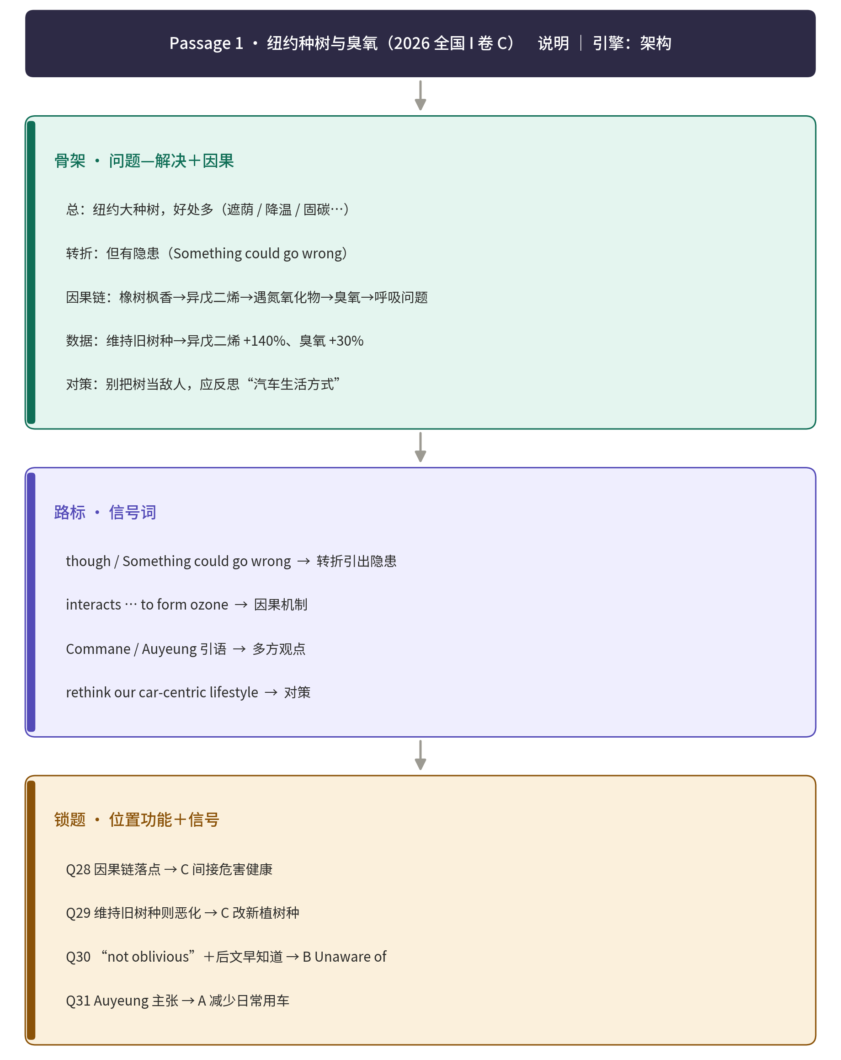

（2026年全国高考1卷D篇）
D
A team of Cambridge psychologists conducted an experiment to compare the cognitive（认知的）effects of merely seeing art with actively judging how beautiful it is.
In the study, 187 people were invited to visit Kettle's Yard gallery during an exhibition of handmade clay objects. Participants were randomly divided into two groups: the "beauty" group was asked to actively consider and then rate the beauty of each object they viewed, while the control group just matched a line drawing of the object with the artwork itself. All participants were then tested on how they process information, and whether it's in a more practical or abstract way.
Across all participants, those in the beauty group scored almost 14% higher on average than the control group in abstract thinking. While they were told the study was about cognitive processes, participants were asked about interests, with around half saying they had an artistic hobby. Among those, the effect was greater: those with an artistic hobby in the beauty group scored over 25% higher on average for abstract thinking than those with an artistic hobby in the control group.
Emotional states of participants were also measured by asking about their feelings while completing the gallery task. Across all participants, those in the beauty group reported an average of 23% higher levels of "transformative and self-transcendent feelings" — such as feeling moved, enlightened and inspired — than the control group. Importantly, however, the beauty group did not report feeling any happier than the control group, suggesting that it was the engagement with beauty that influenced abstract thinking, rather than any overall positivity from the experience.
"We usually think in very concrete terms when doing something on a screen," said Simone Schnall, senior author of the study. "It's becoming much rarer to zone out and just let the mind wander, but that's when we think in ways that broaden our minds. Admiring the beauty of art may be the ideal way to initiate the abstract cognitive processes."
32. What was the beauty group asked to do with the clay objects?
A. Draw their outlines. B. Give each piece a rating.
C. Compare their prices. D. Make a copy of each piece.
33. Which participants got the highest score on average in the test?
A. Beauty group, with an artistic hobby. B. Beauty group, without an artistic hobby.
C. Control group, with an artistic hobby. D. Control group, without an artistic hobby.
34. Why were the participants' emotional states measured?
A. To discover their attitudes towards art. B. To identify their specific thinking patterns.
C. To examine the difficulty of the tasks. D. To determine factors behind the test results.
35. What is the major finding of the study regarding the appreciation of art?
A. It enhances emotional ties. B. It needs critical thinking skills.
C. It creates positive feelings. D. It encourages abstract thinking.
▸ 结构拆解 · 骨架 → 路标 → 锁题
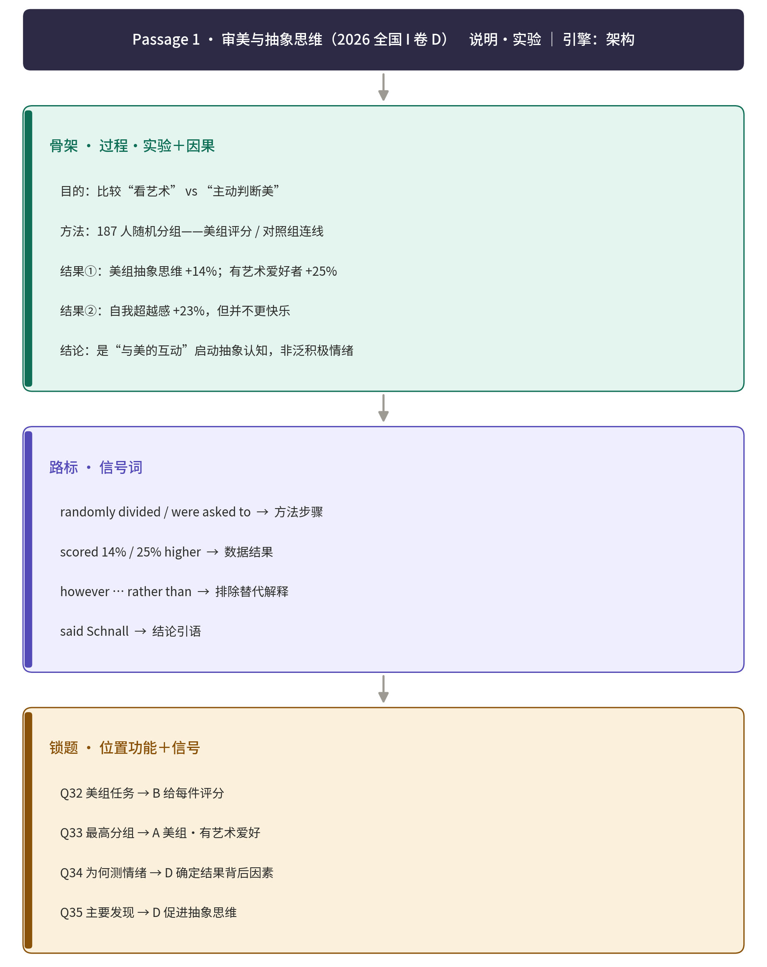

（2025年全国高考I卷D篇）
Microplastics have become a common source of pollution across the Earth — they have settled in the deep sea and on the Himalayas, stuck inside volcanic rocks, filled the stomachs of seabirds and even fallen in fresh Antarctic snow. They are even appearing inside humans.
Now, new research suggests that a simple, cheap measure may significantly reduce the level of microplastics in water from your tap (水龙头): boiling and filtering (过滤) it. In a study published Wednesday in Environmental Science & Technology Letters, researchers from China found that boiling tap water for just five minutes — then filtering it after it cools — could remove at least 80 percent of its microplastics.
Crucially, this process relies on the water containing enough calcium carbonate (碳酸钙) to trap the plastics. In the study, boiling hard water containing 300 milligrams of calcium carbonate led to an almost 90 percent drop in plastics. But in samples with less than 60 milligrams of calcium carbonate, boiling reduced the level of plastics by just 25 percent. Additionally, the research didn’t include all types of plastics. The team focused only on three common types — polystyrene, polyethylene and polypropylene — and they didn’t study other chemicals previously found in water such as vinyl chloride.
Still, the findings show a potential path forward for reducing microplastic exposure — a task that’s becoming increasingly difficult. Even bottled water, scientists found earlier this year, contains 10 to 1,000 times more microplastics than originally thought.
Scientists are still trying to determine how harmful microplastics are — but what they do know has raised concerns. The new study suggests boiling tap water could be a tool to limit intake. “The way they demonstrated how microplastics were trapped through the boiling process was nice,” Caroline Gauchotte-Lindsay, an environmental engineer of the University of Glasgow in Scotland who was not involved in the research, tells New Scientist. “We should be looking into upgrading drinking water treatment plants so they remove microplastics.”

32. How does the author present the issue in the first paragraph?
A. By quoting an expert. B. By defining a concept.
C. By giving examples. D. By providing statistics.

33. What determines the effectiveness of trapping microplastics in water?
A. The hardness of water. B. The length of cooling time.
C. The frequency of filtering. D. The type of plastic in water.

34. What does the author try to illustrate by mentioning bottled water in paragraph 4?
A. The importance of plastic recycling. B. The severity of the microplastic problem.
C. The danger in overusing pure water. D. The difficulty in treating polluted water.

35. What is Gauchotte-Lindsay’s suggestion about?
A. Choice of new research methods. B. Possible direction for further study.
C. Need to involve more researchers. D. Potential application of the findings.
▸ 结构拆解 · 骨架 → 路标 → 锁题
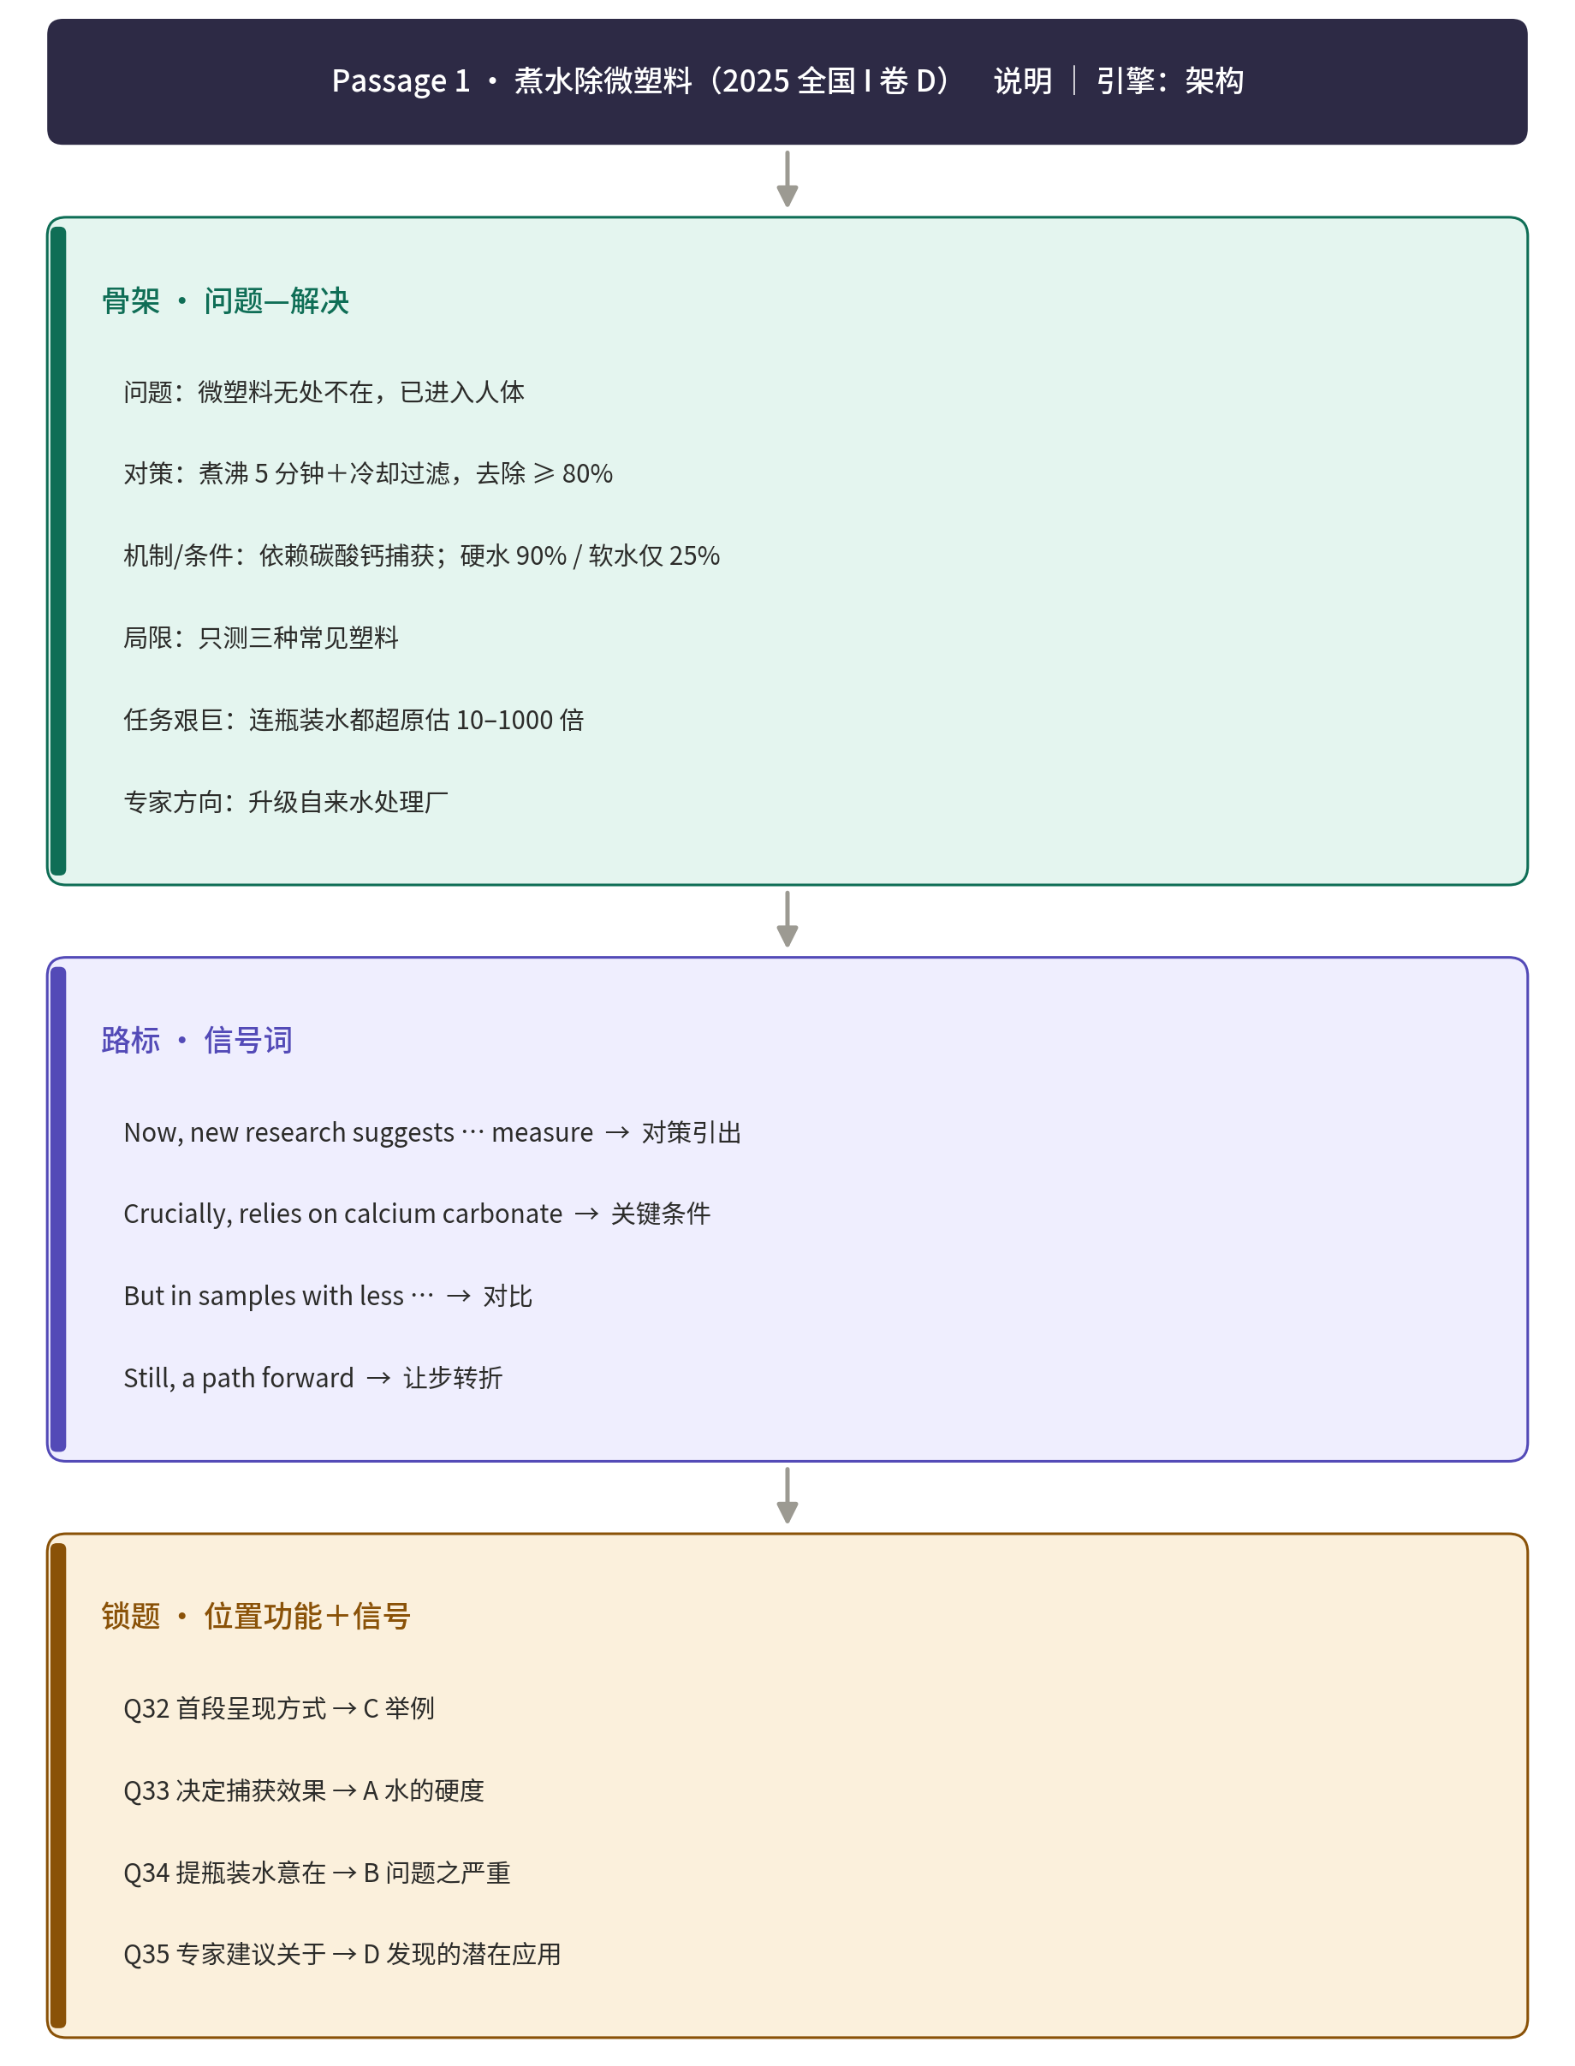

Passage 2
（2025年全国高考I卷C篇）

While safety improvements might have been made to our streets in recent years, transport studies also show declines in pedestrian (行人) mobility, especially among young children. Many parents say there’s too much traffic on the roads for their children to walk safely to school, so they pack them into the car instead.
Dutch authors Thalia Verkade and Marco te Brömmelstroet are bothered by facts like these. In their new book Movement: How to Take Back Our Streets and Transform Our Lives, they call for a rethink of our streets and the role they play in our lives.
Life on city streets started to change decades ago. Whole neighbourhoods were destroyed to make way for new road networks and kids had to play elsewhere. Some communities fought back. Most famously, a Canadian journalist who had moved her family to Manhattan in the early 1950s led a campaign to stop the destruction of her local park. Describing her alarm at its proposed replacement with an expressway, Jane Jacobs called on her mayor (市长) to champion “New York as a decent place to live, and not just rush through.” Similar campaigns occurred in Australia in the late 1960s and 1970s as well.
Although these campaigns were widespread, the reality is that the majority of the western cities were completely redesigned around the needs of the motor car. The number of cars on roads has been increasing rapidly. In Australia we now have over twenty million cars for just over twenty-six million people, among the highest rate of car ownership in the world.
We invest a lot in roads that help us rush through, but we fail to account for the true costs. Do we really recognise what it costs us as a society when children can’t move safely around our communities? The authors of Movement have it right: it’s time to think differently about that street outside your front door.

28. What phenomenon does the author point out in paragraph 1?
A. Cars often get stuck on the road. B. Traffic accidents occur frequently.
C. People walk less and drive more. D. Pedestrians fail to follow the rules.

29. What were the Canadian journalist and other campaigners trying to do?
A. Keep their cities livable. B. Promote cultural diversity.
C. Help the needy families. D. Make expressways accessible.

30. What can be inferred about the campaigns in Australia in the late 1960s and 1970s?
A. They boosted the sales of cars. B. They turned out largely ineffective.
C. They won government support. D. They advocated building new parks.

31. What can be a suitable title for the text?
A. Why the Rush? B. What’s Next?
C. Where to Stay? D. Who to Blame?
▸ 结构拆解 · 骨架 → 路标 → 锁题
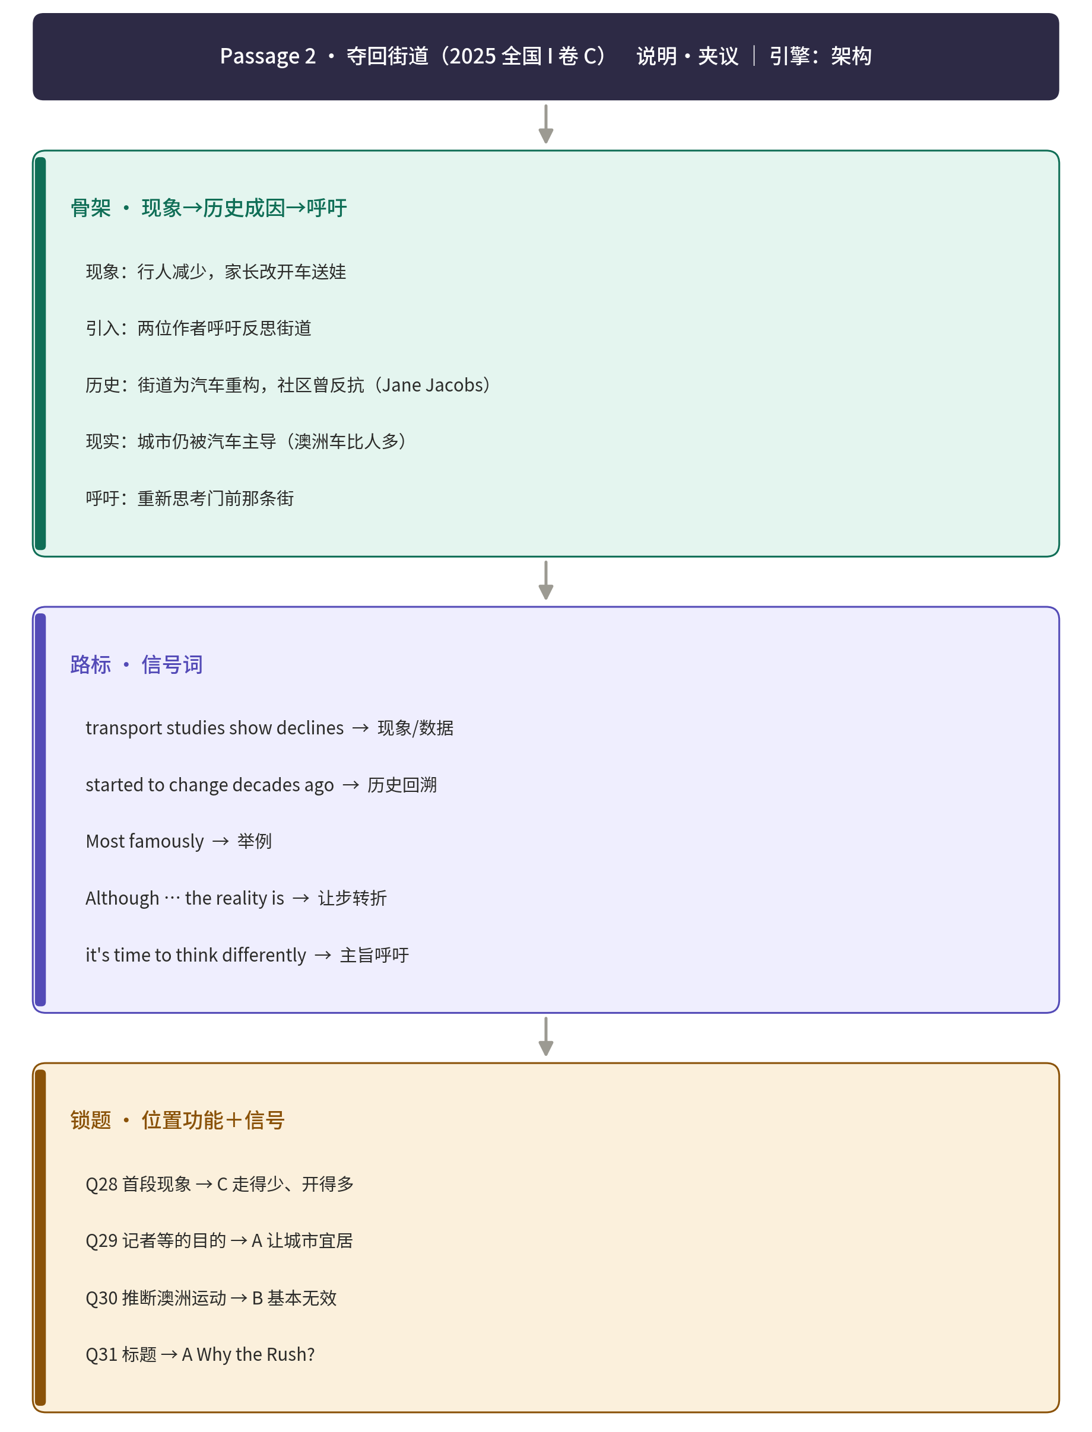

Passage3
（华大新高考联盟3月联考试题）
Contextualism(语境主义) has a long history in historiography (历史编纂学), dating back to the work of historians such as Leopold von Ranke in the 19th century. His emphasis on understanding historical events as they actually were laid the groundwork for the development of contextualist approaches to historical interpretation. In the 20th century, historians such as Quentin Skinner and J. G. A. Pocock further developed contextualist approaches, emphasizing the importance of understanding historical texts and events within their specific linguistic and cultural contexts.
A contextualist approach to historical interpretation requires a deep understanding of the cultural, social, and time context in which historical events occurred. This involves considering factors such as the cultural standards and values of the time, the social structures and institutions that shaped historical events, and the time context, including the specific historical period and any relevant events or trends.
One of the key challenges of historical interpretation is avoiding anachronism (时代错位) and presentism. Anachronism involves putting modern concepts, values, or beliefs onto historical figures or events, while presentism involves judging historical events by modern standards. A contextualist approach helps historians avoid these errors by emphasizing the importance of understanding historical events within their specific context. For example, it would be anachronistic to put modern ideas of human rights onto historical figures such as Thomas Jefferson, who owned slaves yet became the leading author of the United States Declaration of Independence. Instead, historians must consider Jefferson's actions within the context of his time, taking into account the popular attitudes towards slavery and human rights.
While contextualism is a powerful approach to historical interpretation, it is not without its challenges and limitations. Some of the key challenges include: the complexity of reconstructing historical context, which can be incomplete; the risk of cultural and historical relativism, which can make it difficult to evaluate certain historical events critically; the challenge of balancing contextual understanding with the need to draw broader conclusions and lessons from historical events.

32. What did Skinner and Pocock contribute to contextualism?
A. They clarified its definition. B. They demonstrated its logic.
C. They expanded its applications. D. They emphasized its objectives.

33. Which factor may belong to the social context?
A. Strict laws and regulations. B. Unusual customs and fashions.
C. Social values and judgments. D. Linguistic symbols and habits.

34. What does the author imply in paragraph 3?
A. Jefferson ignored human rights. B. Causes behind actions were key.
C. Presentism mislabels past events. D. Subjectivity was uneasy to resist.

35. Why is contextualism an imperfect approach?
A. It may reach a narrow conclusion. B. It infers with second-hand records.
C. It digs into some pointless elements. D. It may find excuses for subjectivity.
▸ 结构拆解 · 骨架 → 路标 → 锁题
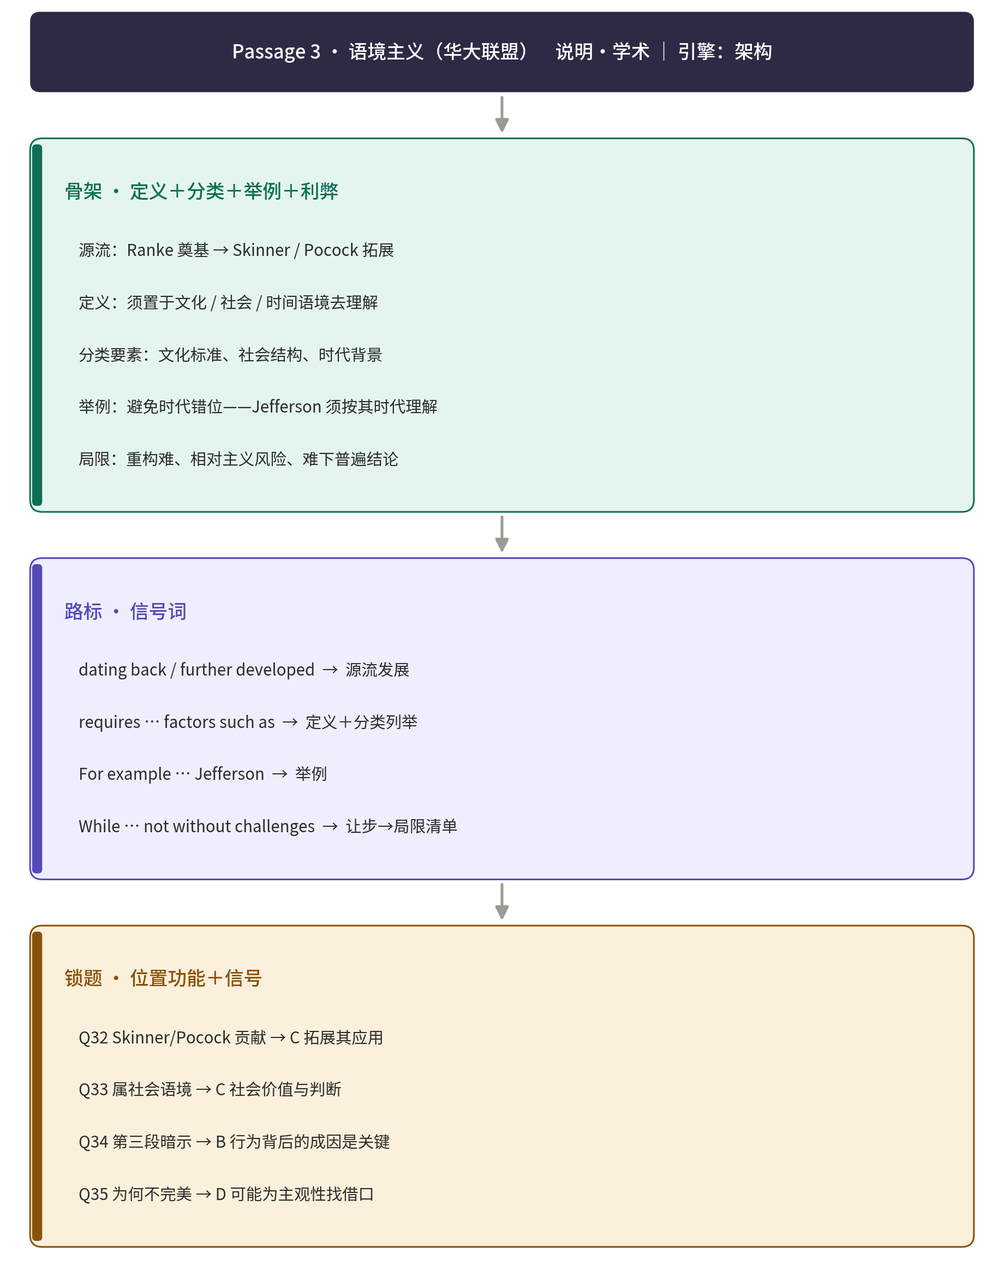

Passage 4
（长郡中学2026届高三月考试卷(二)）
A new study mapping the planetary boundary of “functional biosphere(生物圈) integrity”in spatial detail and over centuries finds that human activity has pushed most of Earth's land beyond safe biosphere limits.The study was led by the Potsdam Institute for Climate Impact Research(PIK)together with BOKU University in Vienna and published in the journal One Earth.
Functional biosphere integrity refers to the plant world's ability to co-regulate(共 调)the state of the Earth system.It requires the plant world to acquire enough energy through photosynthesis(光合作用)to maintain the material flows of carbon,water and nitrogen(氮)that support the ecosystems and their networked processes.Energy flows drive all of life,but humans are disturbing nature's dynamic processes.
Based on the global biosphere model LPJmL,which simulates water,carbon and nitrogen flows on a daily basis,the study provides a detailed image for each year since the 1600.The research team also evaluated two indicators(stress indicator and risk indicator)by comparing with other measures from the literature for which“critical thresholds (阈)" are known.This resulted in each global land area being assigned a status:Safe Operating Space,Zone of Increasing Risk or High Risk Zone.
The model calculation shows that worrying developments began as early as 1600 in the mid-latitudes(纬度).By 1900,the Increasing-Risk Zone and the High-Risk Zone accounted for 37% and 14% respectively, compared to 60% and 38% today.Industrialization was beginning to take its toll;land use affected the state of the Earth system much earlier than climate warming.At present,this biosphere boundary has been broken on almost all land surface primarily in Europe,Asia and North America—that underwent strong land cover changes,mainly due to agriculture.
“This is a breakthrough from a scientific perspective, offering a better overall understanding of planetary boundaries,"says Johan Rockström,one of the co-authors of the study."It also inspires further development of international climate policy."

32.What is functional biosphere integrity mainly about?
A.The smoothness of material flows within the plant world.
B.The stability of plant species covering lands of the Earth.
C.The harmony between the plant world and life-supporting systems.
D.The diversity of materials produced by the plant world on the Earth.

33.What does paragraph 3 mainly talk about?
A.What challenges the researchers met with.
B.How the research was scientifically conducted.
C.When the stress and risk came up for the first time.
D.Why global land areas were at different risk levels.

34.Which of the following probably shows the broken biosphere in 1900?

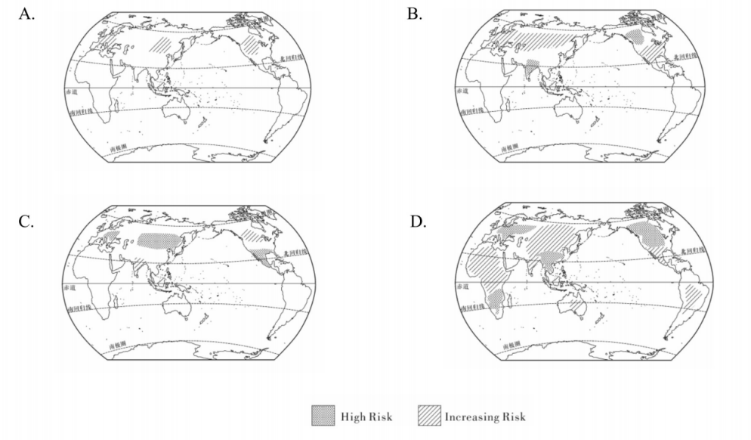
35.What is Johan Rockström's attitude towards the study?
A.Skeptical. B.Objective. C.Unclear. D.Favorable.
▸ 结构拆解 · 骨架 → 路标 → 锁题
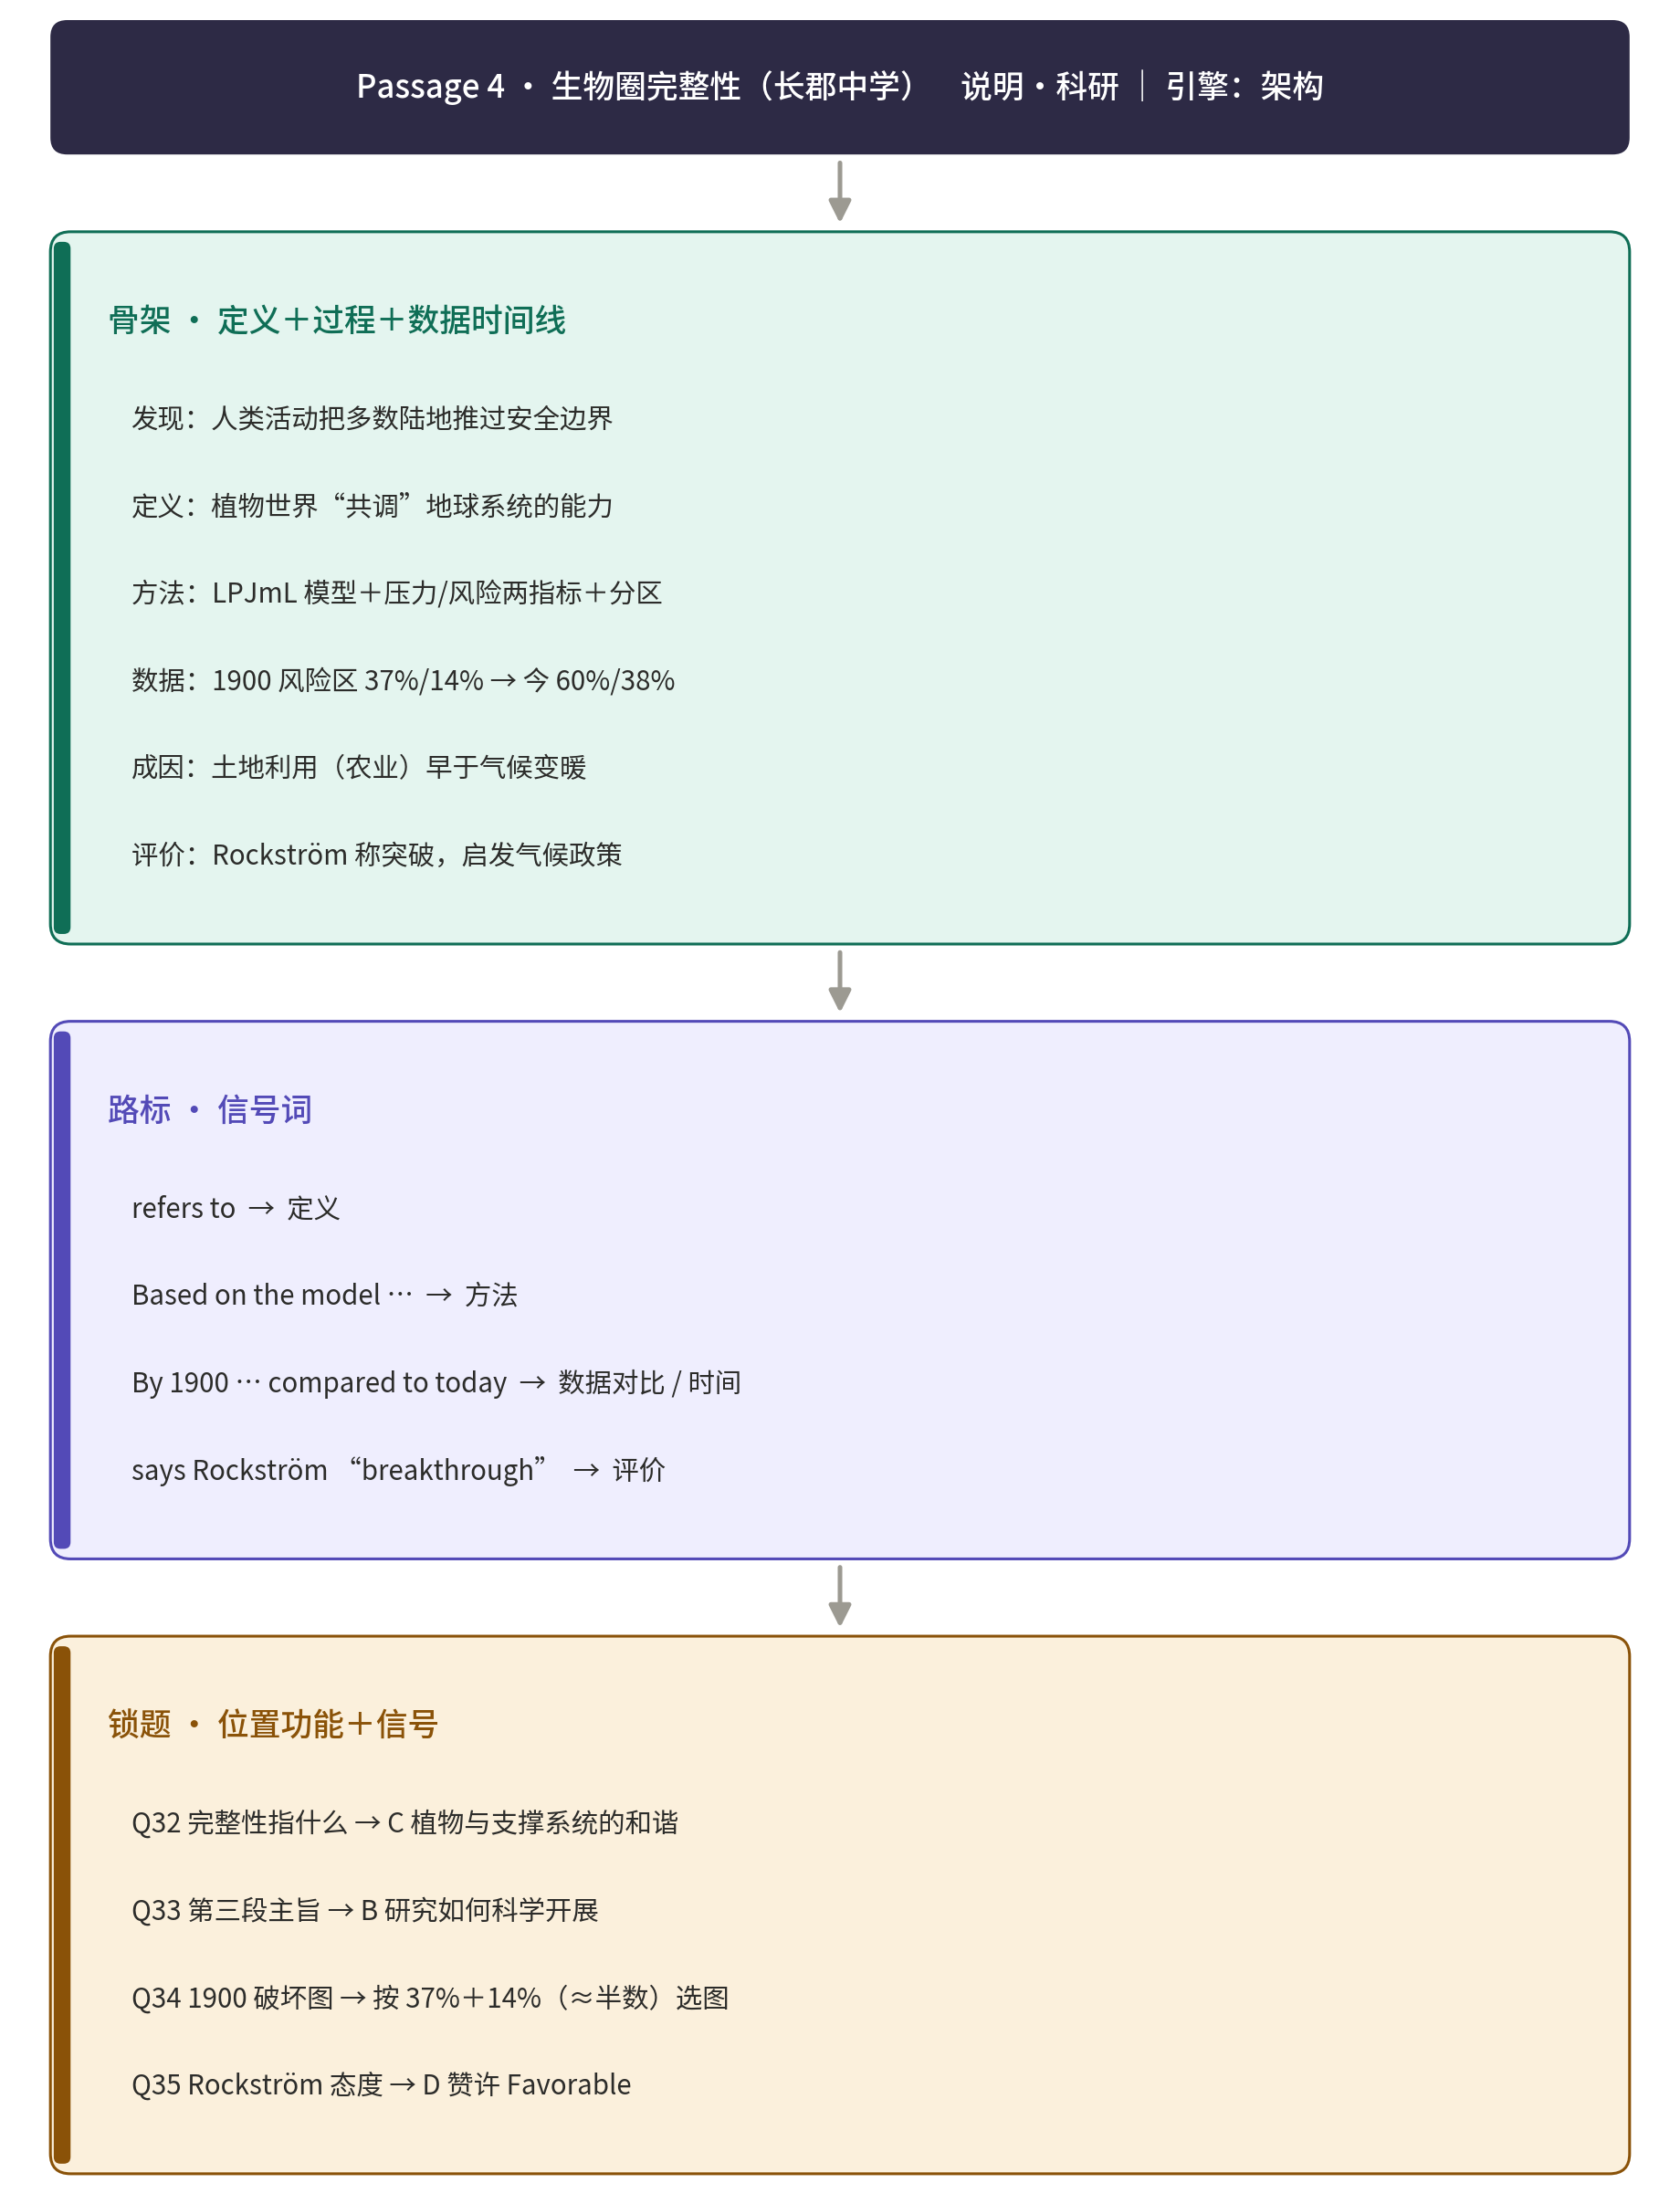

Passage 5
（来源：2026年1月浙江首考真题）
Carbon removal is crucial for fighting climate change. Scientists at Salk Institute are making use of the natural capacity of plants to absorb carbon dioxide by enhancing their root systems. This optimization (优化) aims to increase the amount of carbon stored and extend the duration of its storage.
To design these climate-saving plants, the scientists are using a research tool called SLEAP—an AI software that tracks multiple features of root growth. Created by Salk Fellow Talmo Pereira, SLEAP was initially designed to track animal movement in the lab. Now, Pereira has teamed up with plant scientist Professor Wolfgang Busch to apply SLEAP to plants.
In a study published in Plant Phenomics, Busch and Pereira establish a new procedure for using SLEAP to analyze plant root phenotypes—how deep and wide they grow, how massive their root systems become, and other physical qualities. Prior to SLEAP, tracking the physical characteristics of both plants and animals required a lot of labor that slowed the scientific process. SLEAP uses computer vision (the ability for computers to understand images) and deep learning (an AI approach for training a computer to learn and work like the human brain) to help researchers process images much more quickly.
The application of SLEAP to plants has already enabled researchers to establish the most extensive catalog (目录) of plant root phenotypes to date. What’s more, tracking these physical root system characteristics helps scientists find genes (基因) associated with those characteristics, as well as whether multiple root characteristics are determined by the same genes or independently. This allows the Salk team to determine what genes are most beneficial to their plant designs.
“Our cooperation is truly proof of what makes Salk science so special and impactful,” says Pereira. “We’re not just ‘borrowing’ from different disciplines—we’re really putting them on equal footing in order to create something greater than the sum of its parts.”

32. What do the scientists at Salk Institute hope to achieve?
A. Keeping more carbon in plants. B. Optimizing the use of energy.
C. Enhancing biological diversity. D. Reducing carbon absorption.
33. Why did Pereira create SLEAP?
A. To generate plant images. B. To conduct research on animals.
C. To study climate patterns. D. To track features of root growth.

34. What will SLEAP help the scientists do?
A. Pick out diseased plants in the forest. B. Collect samples of plant root systems.
C. Identify genes for desirable plant roots. D. Preserve the genes of endangered plants.

35. What can be inferred from Pereira’s words?
A. Academic disciplines are of equal importance.
B. Computer programming is a must for scientists.
C. Interdisciplinary approach promotes creativity.
D. Cooperation outweighs competition in research.
▸ 结构拆解 · 骨架 → 路标 → 锁题
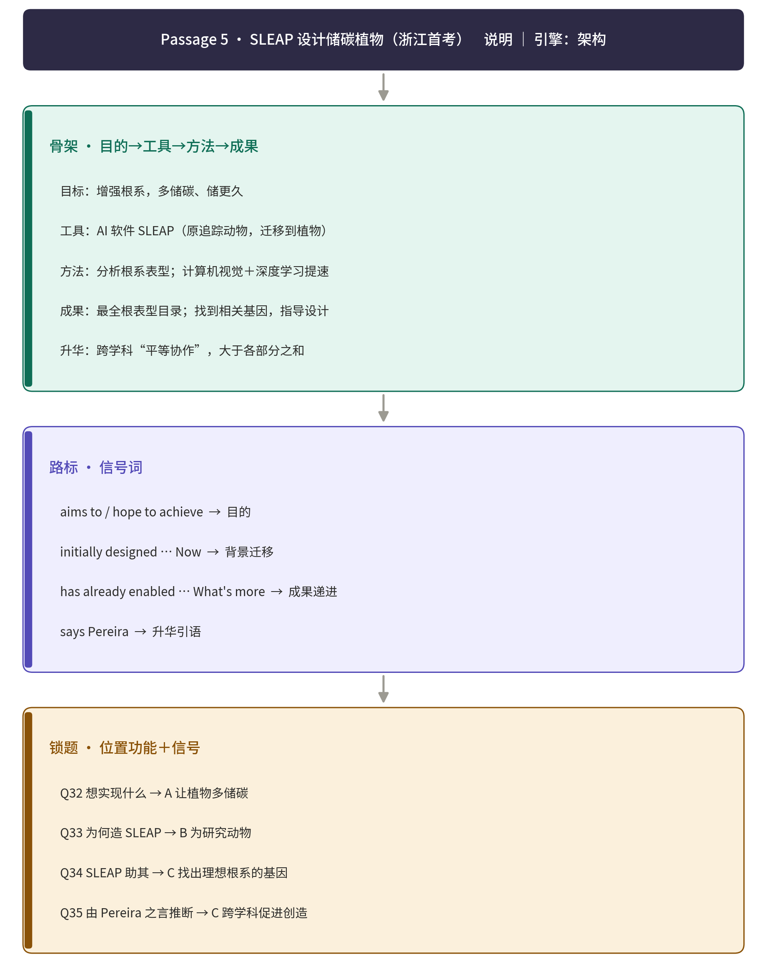

Passage 6
（来源：河北省衡水中学2023级高中毕业班摸底测试英语试题 主题：人与自然）

Advances in artificial intelligence (AI) are indicating that accurate quake forecasting may be attainable, thereby casting doubt on the conventional wisdom that such an accomplishment is beyond our capabilities. Researchers at the University of Texas, Austin, created an AI model that, during a test run in China, correctly forecasted approximately 70 percent of earthquakes with a one-week warning and offered reliable assessments of their potential intensity.
The researchers attribute their technique’s effectiveness to its reliance on a straightforward machine leaning framework. The AI was provided with a set of statistical features based on the team’s knowledge of earthquake physics, and then instructed to train itself using a five-year database of earthquake recordings. Once trained, the AI offered predictions by detecting early indicators of quakes hidden within the planet’s low-frequency rumbles (隆隆声).
The project marks a substantial breakthrough in the exploration of AI for anticipating seismic (地震) events. According to Alexandros Savvaidis, a senior researcher heading the Texas Seismological Network, “Seismic occurrences strike without warning, often in the blink of an eye. Your readiness is all you can influence. Achieving a 70% prediction rate is a considerable achievement that could significantly restrict the impact of earthquakes, reducing both the financial burden and loss of life, and the potential to remarkably improve earthquake preparation worldwide.”
Although the effectiveness of this method in different regions remains uncertain, the researchers believe that their AI model has the potential to enhance prediction accuracy when carried out in regions equipped with dependable seismic monitoring facilities. Their next step is to test artificial intelligence in Texas, where the University of Texas’s TexNet operates a network of 300 earthquake stations and over six years’ worth of continuous records, making it an ideal location for these purposes.
Ultimately, the authors aim to combine the system with physics-based models. This approach could be particularly valuable in areas characterized by limited or inadequate data. “That may be a long way off, but many advances such as this one, taken together, are what moves science forward,” concludes Scott Tinker, the bureau’s director.

32. How does the AI predict seismic events?
A. It identifies data from the satellites.
B. It analyzes background sounds in the Earth.
C. It models data based on earthquake recordings.
D. It monitors changes in the Earth’s magnetic field.

33 What does Alexandros Savvaidis intend to show in paragraph 3?
A. The ways to reduce losses in earthquakes.
B. The importance of preparing for earthquakes.
C. The significance of developing the AI prediction.
D. The restrictions of AI-based methods in earthquake prediction.

34. What does the subsequent research focus on?
A. Conducting tests in different locations.
B. Applying the AI approach to other fields.
C. Building more earthquake stations in Texas.
D. Enlarging the database to train the calculation accuracy.

35. Which words can best describe the earthquake-predicting technology?
A. Stable but outdated. B. Effective but costly.
C. Potential and economical. D. Pioneering and promising.
▸ 结构拆解 · 骨架 → 路标 → 锁题


