Passage 1
（2024年全国高考I卷C篇）
Is comprehension the same whether a person reads a text onscreen or on paper? And are listening to and viewing content as effective as reading the written word when covering the same material? The answers to both questions are often “no”. The reasons relate to a variety of factors, including reduced concentration, an entertainment mindset (心态) and a tendency to multitask while consuming digital content.
When reading texts of several hundred words or more, learning is generally more successful when it’s on paper than onscreen. A large amount of research confirms this finding. The benefits of print reading particularly shine through when experimenters move from posing simple tasks — like identifying the main idea in a reading passage — to ones that require mental abstraction — such as drawing inferences from a text.
The differences between print and digital reading results are partly related to paper’s physical properties. With paper, there is a literal laying on of hands, along with the visual geography of distinct pages. People often link their memory of what they’ve read to how far into the book it was or where it was on the page.
But equally important is the mental aspect. Reading researchers have proposed a theory called “shallowing hypothesis (假说)”. According to this theory, people approach digital texts with a mindset suited to social media, which are often not so serious, and devote less mental effort than when they are reading print.
Audio (音频) and video can feel more engaging than text, and so university teachers increasingly turn to these technologies — say, assigning an online talk instead of an article by the same person. However, psychologists have demonstrated that when adults read news stories, they remember more of the content than if they listen to or view identical pieces.
Digital texts, audio and video all have educational roles, especially when providing resources not available in print. However, for maximizing learning where mental focus and reflection are called for, educators shouldn’t assume all media are the same, even when they contain identical words.

28. What does the underlined phrase “shine through” in paragraph 2 mean?
A. Seem unlikely to last. B. Seem hard to explain.
C. Become ready to use. D. Become easy to notice.

29. What does the shallowing hypothesis assume?
A. Readers treat digital texts lightly. B. Digital texts are simpler to understand.
C. People select digital texts randomly. D. Digital texts are suitable for social media.

30. Why are audio and video increasingly used by university teachers?
A. They can hold students' attention. B. They are more convenient to prepare.
C. They help develop advanced skills. D. They are more informative than text.
31. What does the author imply in the last paragraph?
A. Students should apply multiple learning techniques.
B. Teachers should produce their own teaching material.
C. Print texts cannot be entirely replaced in education.
D. Education outside the classroom cannot be ignored.
▸ 结构拆解 · 骨架 → 路标 → 锁题
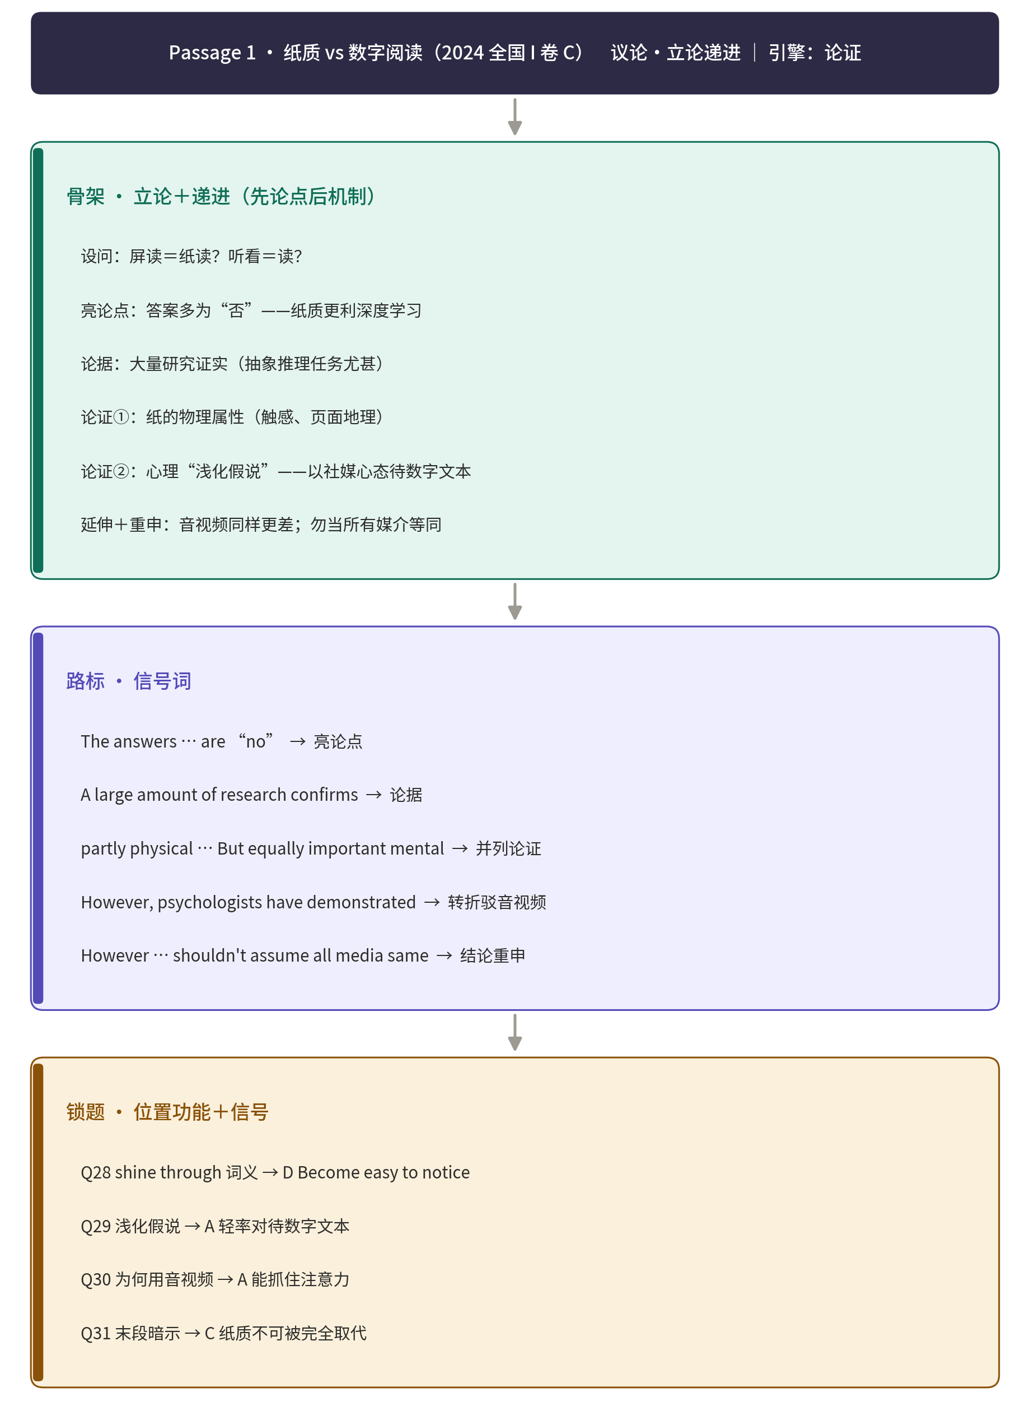
Passage 2
（来源：江苏省南京市六校联合体2026届高三上学期月学情调研英语试题）
Critical thinking influences our daily lives more extensively than we typically acknowledge. Even common decisions, such as selecting a breakfast, involve subconscious (下意识的) application of critical thinking as we weigh factors like nutrition, taste preferences, and dietary needs to determine the best option for that particular morning.​
This ability functions much like a muscle—it strengthens progressively with deliberate practice. As a cornerstone of professional success, critical thinking equips individuals with the capacity to navigate workplace challenges, systematically test hypotheses (假说) through continuous trials, and put forward effective solutions to complex problems. Its significance in career advancement cannot be overstated.​
Fundamentally, critical thinking refers to the capacity to comprehend, assess, and analyze factual information to form reasoned judgments or evaluate the validity of claims. Beyond mere curiosity about the world, critical thinkers excel at establishing logical connections between ideas to grasp broader contexts. Developing this skill enables individuals to convey their thoughts logically, present arguments systematically, and make informed decisions helpful to continuous improvement.​
While scientific professions clearly demand critical thinking, its application extends across diverse careers including law, medicine, journalism, engineering, accounting, and analysis. The World Economic Forum consistently identifies it as an important workforce skill due to its role in enhancing information analysis, improving creativity, enabling innovative problem-solving, and advancing strategic planning. In everyday life, critical thinking operates inconspicuously yet powerfully, empowering independent thought and judgment. ​
Contrary to common misconceptions, critical thinking strengthens interpersonal relationships by boosting empathy for others’ perspectives and maintaining an open mindset. Critical thinkers maintain intellectual curiosity, pose inquiring questions, and refuse to accept information at face value. Critical thinking isn’t just a nice-to-have; it’s how we grow, improve, and make sense of an increasingly complex world. It helps us ask better questions, listen more deeply, and approach problems with clarity instead of chaos.

32. Which method best helps develop critical thinking skills according to the passage?
A. Learning through repeated errors. B. Developing stronger emotional awareness.
C. Engaging in focused, intentional practice. D. Making decisions based on subconsciousness.

33. Which example best shows critical thinking?
A. Consumers buy phones just based on ads. B. Doctors analyze tests before treatment.
C. Viewers believe news without confirmation. D. Managers overemphasize certificates in hiring.

34. What does the underlined word “inconspicuously” in paragraph 4 mean?
A. Obviously. B. Precisely. C. Unnoticeably. D. Abstractly.

35. What can be inferred from the last paragraph?
A. Critical thinking helps drive the world forward.
B. Critical thinking harms interpersonal relationships.
C. Critical thinkers refuse to accept basic information.
D. Critical thinkers can put themselves in others’ shoes.
▸ 结构拆解 · 骨架 → 路标 → 锁题
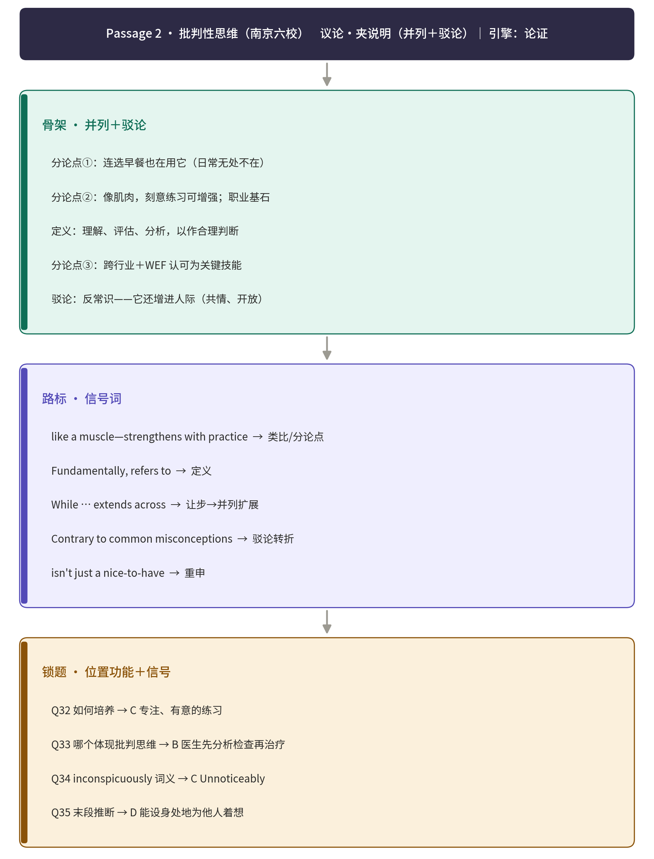
Passage 3
（来源：2026届南通一模）
As digital communication becomes the primary way many people connect, the language we use in these spaces is constantly evolving. Texting has developed its own dialect (方言), filled with abbreviations like "hru?" (how are you?). While nearly all texters use these shortcuts, the findings suggest that dashing off a swift "hru?" might not appear as genuine as taking the time to spell out: "How are you?"
"While abbreviations can save time and effort, our research suggests that they may also slow down effective communication and negatively influence interpersonal perceptions," the authors write in Journal of Experimental Psychology.
The findings challenge the common assumption about texting culture. While 99% of people report using abbreviations and 84% believe others don't mind them, the research shows that abbreviated messages consistently create negative impressions. Perhaps most tellingly, only 15.8% of participants correctly predicted this negative impact, while 80% assumed others would be indifferent to abbreviations.
David Fang at Stanford University and his colleagues ran the studies to explore the impact of abbreviations in different messaging scenarios (情景). They examined over 200,000 conversations from 686 users spanning 37 countries and five continents. Researchers calculated the percentage of abbreviations participants used in their messages. They discovered a clear pattern: conversations containing more abbreviations consistently died out faster.
"Our research reveals that texting abbreviations negatively affect interpersonal communication by decreasing perceived effort, which in turn leads to lower perceived sincerity and responsiveness. Ultimately, our findings highlight the importance of considering the impact of evolving language use in the digital era on the quality of interpersonal communication," Fang and his colleagues concluded.
Texting abbreviations could contribute to loneliness if people find that social bonds weaken over time because they receive less frequent or positive replies to their texts, Fang said. But he doesn't believe people should stop using abbreviations altogether.
"We often tailor the effort we put into conversations to match the significance of the relationship. In some cases, it makes sense to invest less effort, like quickly texting with a delivery driver," Fang said. "However, our findings are especially relevant when we want to strengthen social ties, such as at the beginning of a relationship or when we need to make a good impression."

28.What do the findings indicate about texting abbreviations?
A. They make senders seem insincere. B. They have evolved over a long time.
C. They reshape digital communication. D. They are a shortcut to learning dialects.
29.What do texters commonly assume about abbreviations?
A. They could become trendy. B. They would not bother others.
C. They could ruin communication. D. They would damage social connections.
30.Fang's research reveals that the use of abbreviations is perceived as
A. the evolution of language B. a lower effort from the sender
C. an improved conversational quality D. the preference for a shorter conversation
31.What is Fang's view on using abbreviations?
A. It enhances social ties. B. It should be abandoned.
C. It depends on the context. D. It can simplify the content.
▸ 结构拆解 · 骨架 → 路标 → 锁题
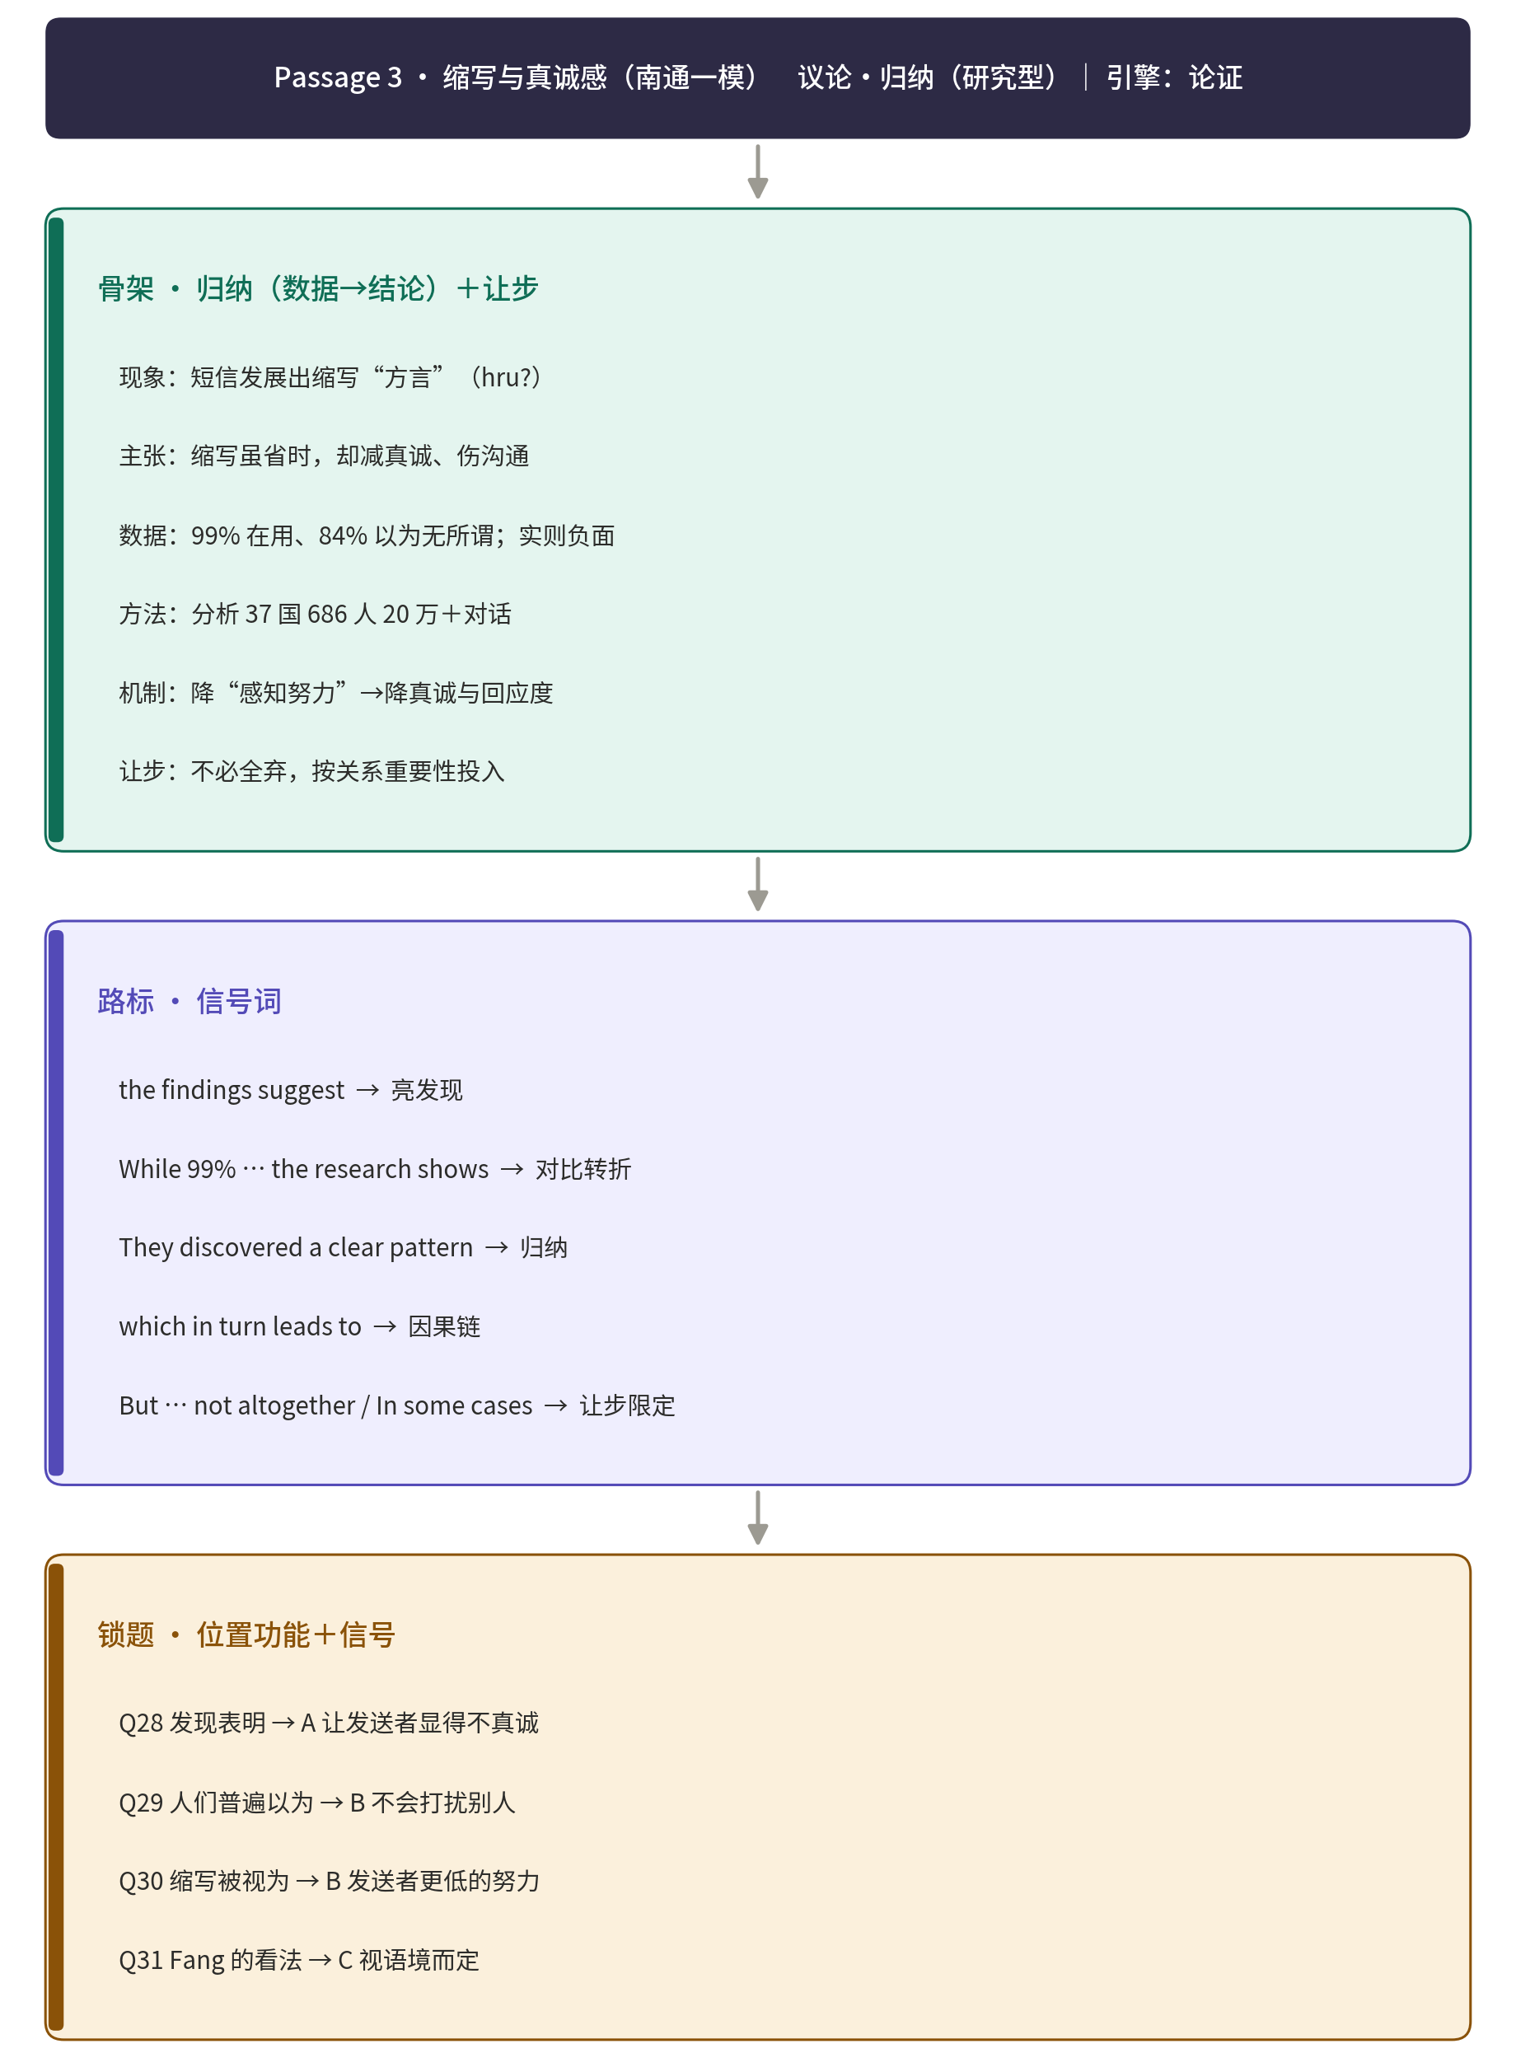

Passage 4
（来源：2026届南通一模）
Ask Google’s AI video tool to create a film of a time-travelling doctor who flies around in a blue British phone booth and the result, unsurprisingly, resembles Doctor Who. And if you ask OpenAI’s technology to do the same, a similar thing happens. What’s wrong with that, you may think? The answer could be one of the biggest issues AI chiefs face as their era-defining technology becomes ever more widespread in our lives.
Google and OpenAI’s generative artificial intelligence is supposed to be just that — generative, meaning it develops novel answers to our questions. But how much of that output is original? The problem is working out how much AI tools like Sora 2 and Veo 3 rely on someone else’s art to come up with their own inventions. One firm, however, claims to be able to shine a light on the issue.
TraceID by Vermillio can detect the percentage to which AI-generated content is based on copyrighted materials. One of the platform’s abilities is to create neural fingerprints for brands, characters or other IP. These fingerprints act as digital identifiers that map the unique characteristics of a given piece of content. By comparing this fingerprint against AI-generated content, it can determine how much the new content overlaps with the original, offering a percentage-based match.
The research showcases this process in action, using well-known films such as Doctor Who and James Bond as case studies. The findings? Sora matched up to 62% with James Bond fingerprint, Google’s Veo 3 matched 80% to Doctor Who fingerprint, implying that they have leaned heavily on copyright-protected work to produce its output.
Many creative professionals demand compensation and an end to unauthorized use of their work until permissions are granted. They argue AI tools build on their work without remuneration, producing competing creations that undercut their industries.
Kathleen Grace, head of Vermillio, said: “We can all win if we just take a beat and figure out a way to share and track content. This would encourage copyright holders to release more data to AI companies and would give AI companies access to more interesting sets of data. Instead of giving all the money to AI companies, there would be this amazing ecosystem.”
32.What issue is presented at the beginning of the passage?
A.Generative AI reinvents film production.
B. The capabilities of generative AI are expanding.
C. Generative AI is becoming increasingly widespread.
D. Copyrighted materials are used in AI-generated content.

33. What is paragraph 3 mainly about?
A. Who uses TraceID. B. How TraceID works.
C. Why TraceID is developed. D. Where TraceID is used.

34. What does the underlined word “remuneration” in paragraph 5 mean?
A. Delay. B. Pay. C. Effort. D. Warning.

35. What message does Kathleen Grace want to convey?
A. Limiting data hurts scientific progress. B. Copyright holders should release more data.
C. A fair data-sharing ecosystem benefits all. D. AI firms must disclose copyrighted content use.
▸ 结构拆解 · 骨架 → 路标 → 锁题
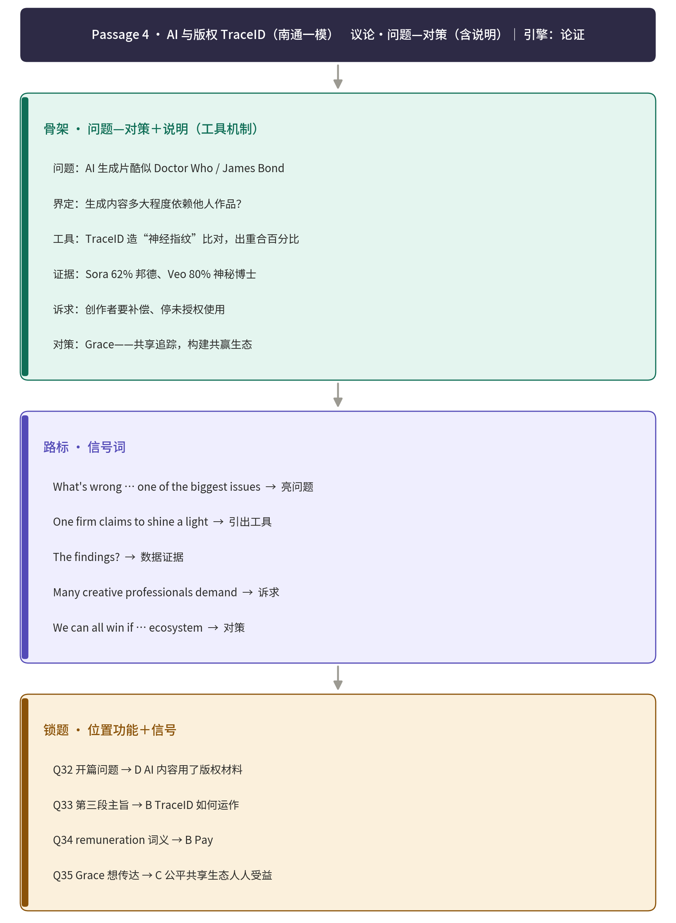

Passage 5
（来源：湖北省高中名校联盟 2026 届高三第一次联合测评 主题：人与社会）
Huge piles of research on diet are published annually. The most shocking of these get reported in the media. All claim to be based on the latest research and each claims to prove the last study wrong. Do scientists really not know what's good for us,or is the news report to blame for the confusion?
Misleading media coverage plays a role,but publication bias( 偏见)is one major source: studies that show surprising results are more likely to get published.“What you see published in the nightly news is the end result of a system where everyone is encouraged to come up with a positive result,”says Vinay at Oregon Science University.
One way to get around this problem is to conduct large, randomized controlled trials, which involve randomly assigning participants to different groups to control variables. But these kinds of studies are difficult to do for foods, as few would risk eating habits on chance; fewer still sustain changes long enough to benefit. Instead, nutrition scientists usually observe what people eat by asking them to fill out food diaries,and then track the health of participants over a given period of time.
In these“observational”studies,people track their diets while going about their lives. Differences between subjects in what they do outside of mealtimes can make all the difference. People who eat what is seen as an unhealthy diet—with more fast food, for instance—might have unhealthy lifestyles in other ways,such as smoking. Consequently, dietary effects are hard to set apart.
Because of these difficulties, even today's most recommended dietary advice lacks good quality evidence. This doesn't mean we can eat as much cake as we like. But it does suggest that within limits of common sense, one way of eating is about as good as another. While admittedly simple advice, it removes the pressure to constantly run after the latest amazing diet or fear seemingly harmful foods. Within reason, trusting your stomach is mostly fine.

28.What phenomenon is presented in paragraph 1?
A.Scientists fail to figure out truth. B.News spreads confusion on purpose.
C.Research on diet astonishes people. D.Media reports conflicting diet studies.

29.Which of the following news items suggests publication bias?
A.Chocolate unexpectedly aids weight loss. B.Calorie restriction helps to slow aging.
C.Effects of zero fat diet require further tests. D.Whole grain diet improves heart health.

30.What do paragraphs 3 and 4 mainly discuss?
A.The reliability of self-reported diet data. B.How long-term diet tracking improves health.
C.The main problems in studying dietary effects.D.How lifestyle factors affect diet research results.

31.What is the author's suggestion for food choice?
A.Avoid potentially unhealthy foods. B.Consume varieties of foods.
C.Count on the latest dietary advice. D.Follow body signals sensibly.
▸ 结构拆解 · 骨架 → 路标 → 锁题
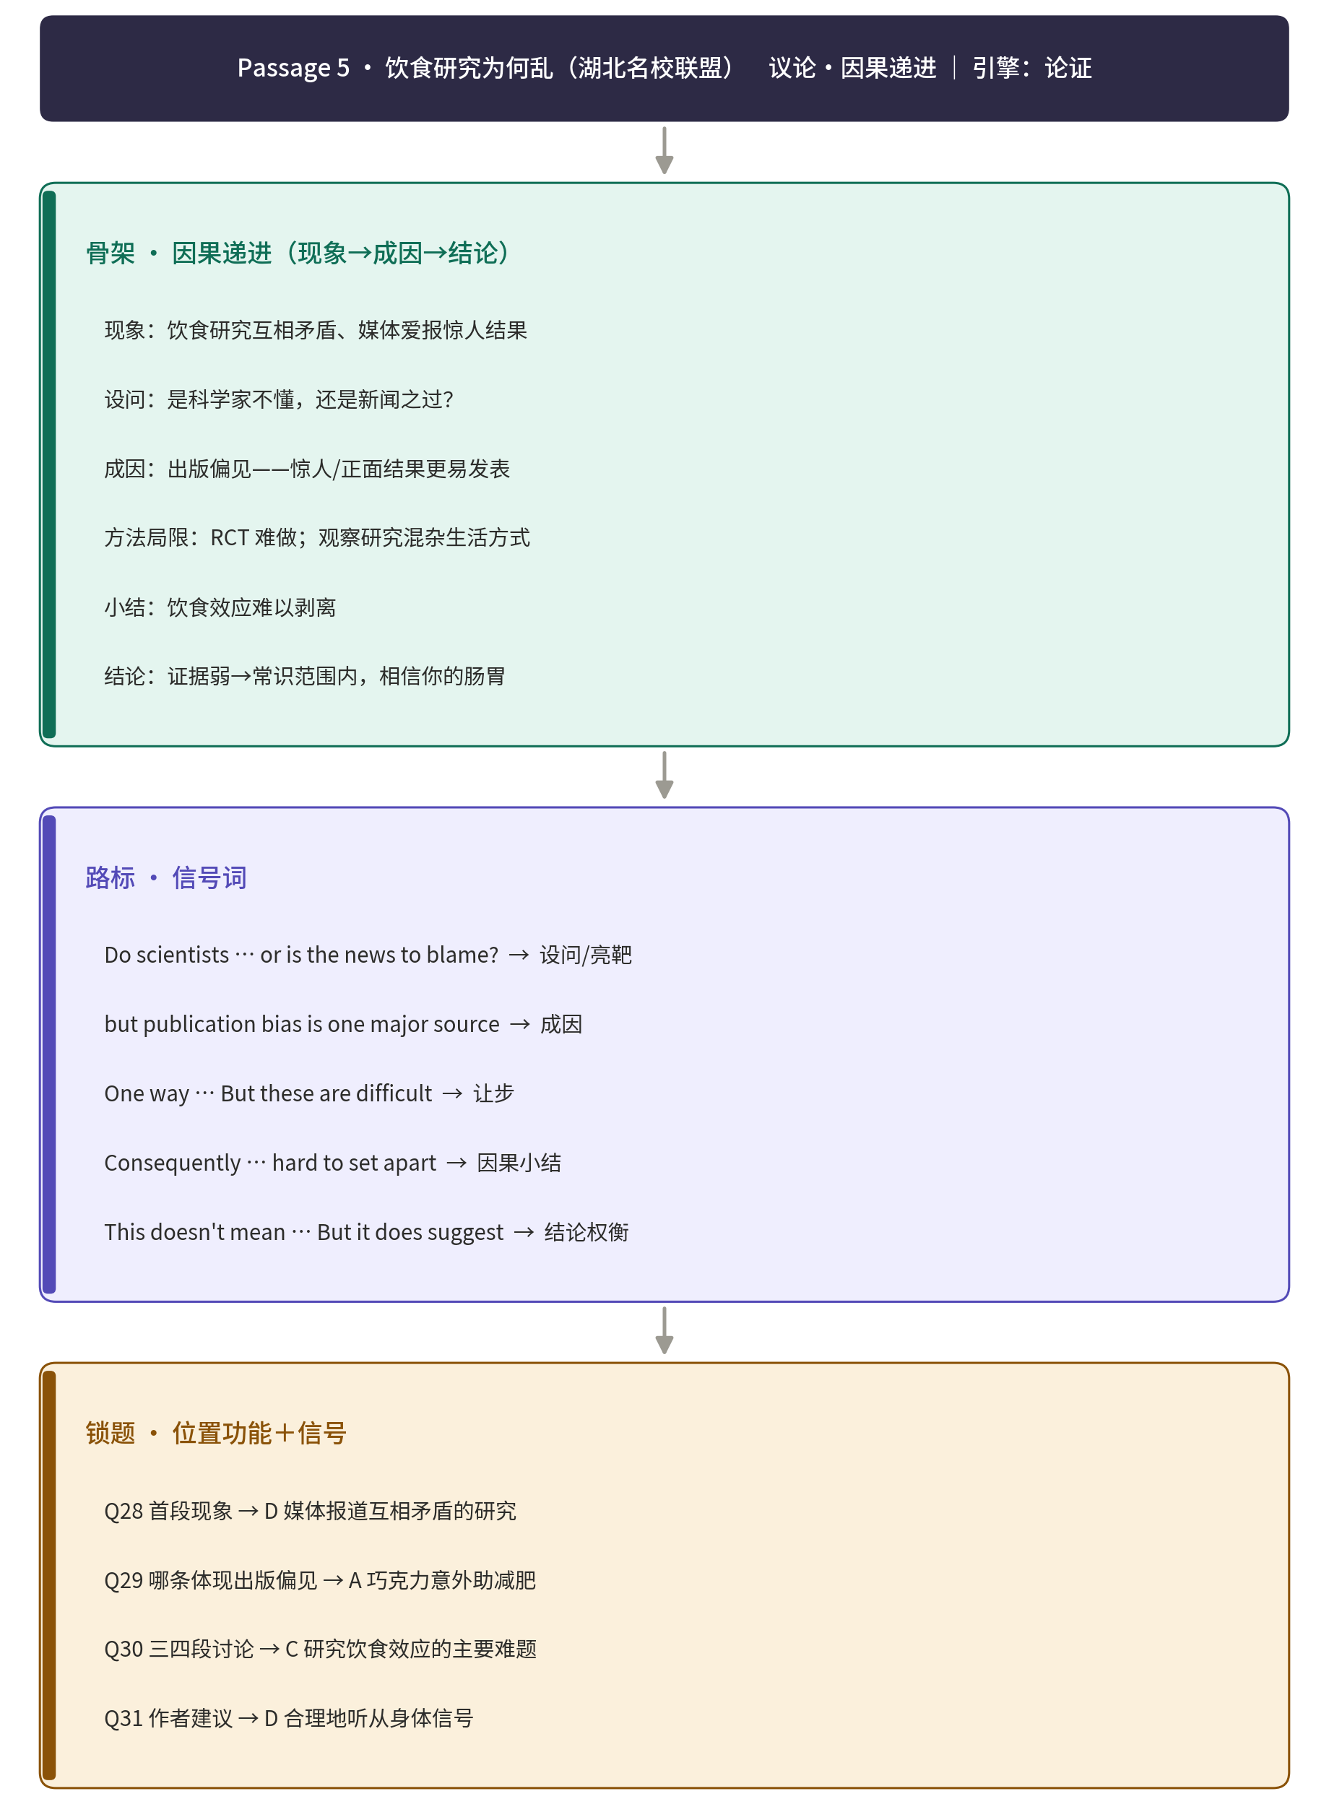

Passage 6
（山东名校联盟高三上学期期中检测试卷）
Ever wondered how social media platforms decide how to fill our feeds? They use algorithms(算法),of course, but how do these algorithms work?In 2021,Frances Haugen,a Facebook product manager secretly took ten thousand pages of documents and internal messages out of Facebook headquarters. She leaked these to a handful of media outlets.A lot of stories soon ran, largely focusing on the most alarming,attention-grabbing secrets.
It turns out that Facebook engineers have assigned a point value to each type of engagement users can perform on a post(liking, commenting, resharing,etc.). Facebook’s algorithm calculates a personalized score for each post to determine its place in the feed.This score is got by multiplying the probability you'll perform each engagement—likes, loves, etc.—by its pre-assigned point value,then summing these products. Posts are then ranked from highest to lowest score,creating your tailored feed.Then the magic formula is: Score = Vlike × Plike + Vlove × Plove + Vangry × Pangry + Vcomment × Pcomment + Vshare × Pshare.
The idea is that the algorithm wants to surface the posts you're most likely to engage with.Have you ever seen a TikTok video with overlaid text saying something like “You won't believe what happens,"or “You've gotta watch till the end?” Some people post videos where literally nothing happens,but they trick you into watching multiple times, thereby winning even more expected seconds.Comments and seconds watched, no matter what quality and kind,tell TikTok's algorithm one thing:“Give me more videos like this.”
Social media algorithms bring the things we engage with closer and closer. Once we start clicking the social media,we're going to be served up a lot more of it.It's a cruel cycle that can quickly turn our feeds into endless streams of digital trash. Knowing how and why this cycle happens is the first step to stop it. Just remember: the tech companies choose the Vs in the social media formula,but the Ps are shaped by your actions online.
28.What does the underlined part in paragraph 1 indicate?
A.The social media were affected. B.The leak went viral immediately.
C.The manager hated Facebook a lot. D.The secret was an eye-catching event.

29.What is paragraph 2 mainly about?
A.Why Facebook designed a formula. B.How Facebook determines our feeds.
C.How the formula was created carefully. D.Why users have to be cautious about posts.

30.What does the author intend to tell us with the TikTok example?
A.Algorithms are smart to track everything.
B.Even unintentional watch can tell about our likes.
C.Some people will do everything to attract attention.
D.TikTok has more powerful algorithms than Facebook.

31.What does the author advise us to do?
A.Focus on the positive videos only.
B.Engage less with the content we hate.
C.Comment more on what we appreciate.
D.Mind our responses to what is fed to us.
▸ 结构拆解 · 骨架 → 路标 → 锁题


